ZERO ZERO LIVE BLOGGER READ ME FILE.

This is a text blog suite that contains most of the functions that should be in a text blog. You can view all the posts but If you want to add posts you must create a account on this blog.

Implantation note.

Before implementation you have to install XAMPP on your PC. Then from its control panel start apache server and MySQL database. Then import the database “blog” from the database folder to the phpmyadmin. Database will import without any errors.(I tested it.SQL file will create the database as well as all the tables, and all the data will be dumped into tables automatically)Then copy all the content to htdocs folder then run it from the browser.

Current usernames and passwords

* (admin) - Username - lakith Password – sumangala
* Username – sachin Password – pass
* Username – hansi Password - pass

Home

Home page of this blogger suite –

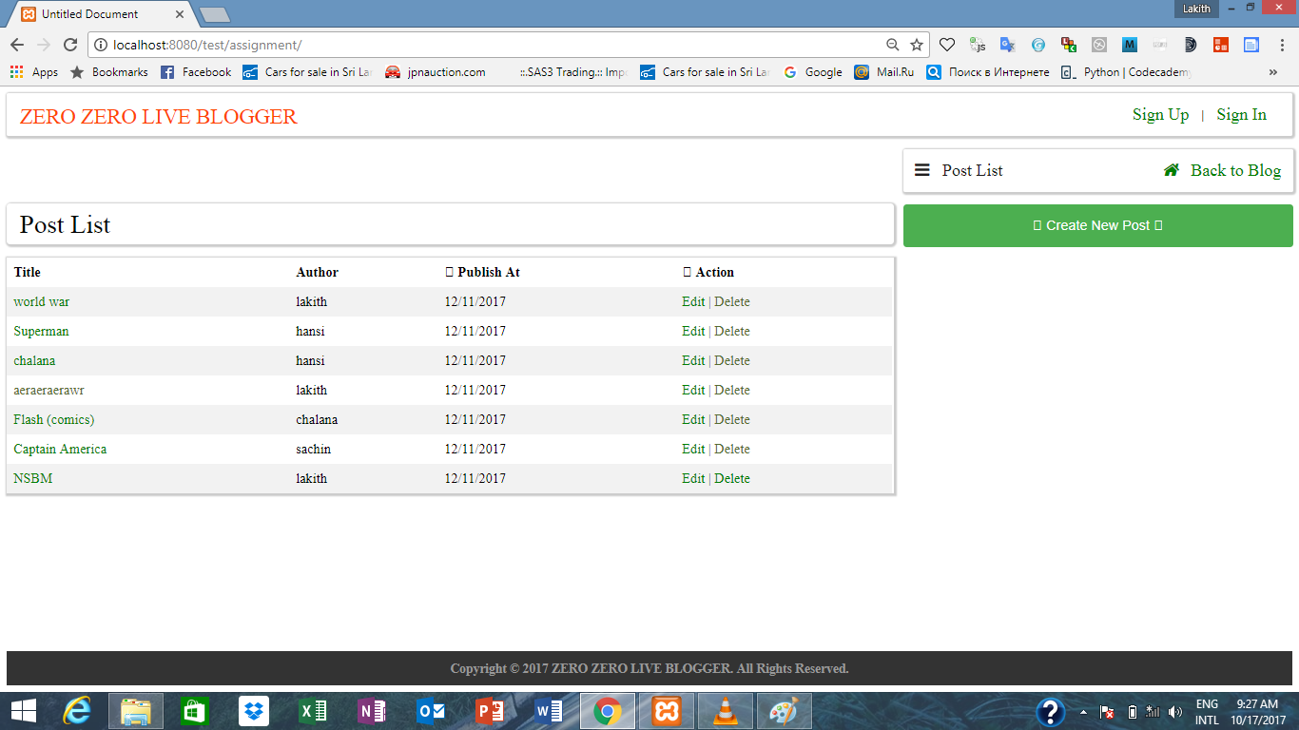

All the users and non users can see this home page. But after login and according to user level home page has slight differences. The post list table dynamically created by retrieving data from the database.

Normal login –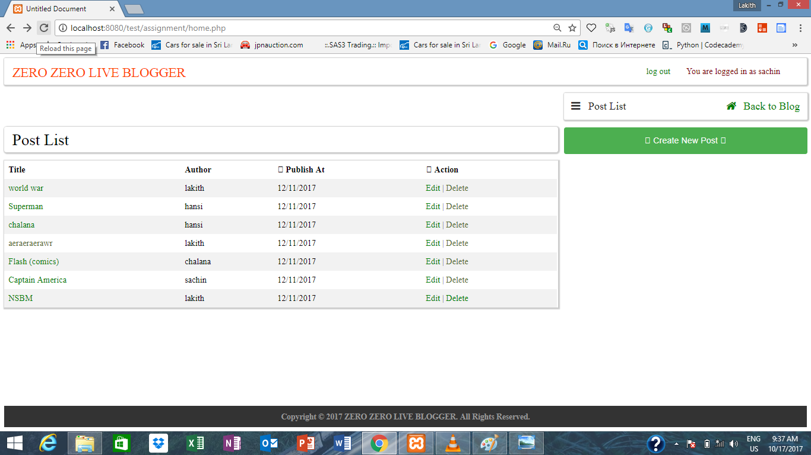

Admin login –

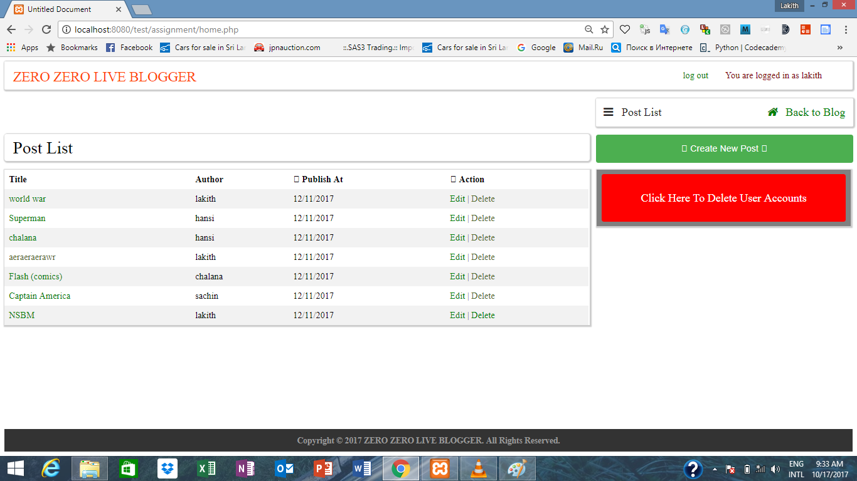

After login to the blog sign in and sign up links will be removed. Because there is no use of sign in again or sign up after login to a account. That function is performed by a simple JavaScript function.

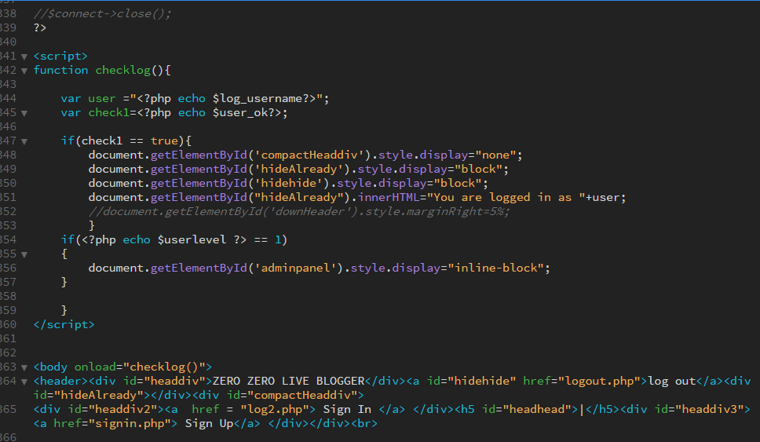

Also according to the user level “Click Here To Delete Users” button also displayed. It is only displayed to the admin users. If a user is an admin his or her user_level is 1.

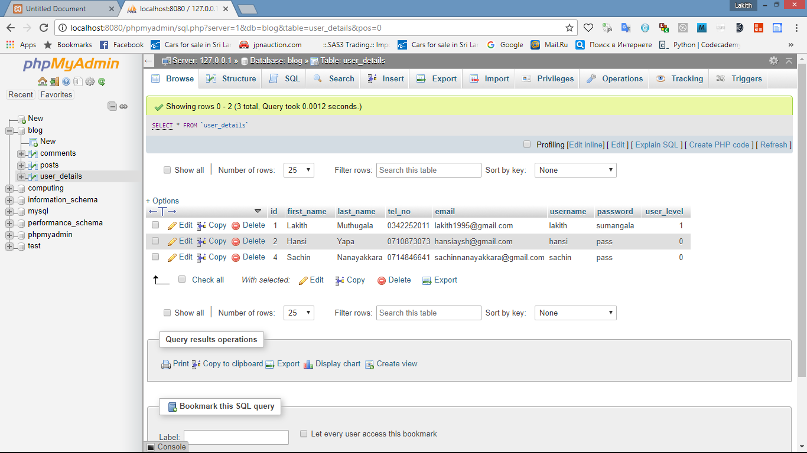

When a user login to his blog cookies and sessions will be created. There for by tracking the sessions and cookies blogger suite is able to keep the user logged in until the cookies and sessions will destroy.

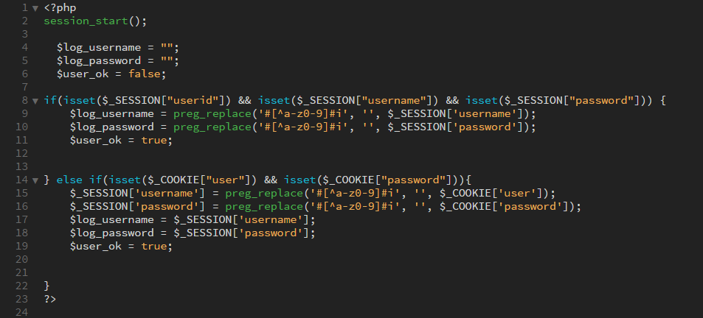

If session is set by copying its values, blogger suite will keep the user logged in , else is there no sessions but cookies, cookies data is copied to session variables , and sessions got created. Then the session data copied to local variables. preg_replace perform a regular expression search and replace. By referring these local variables blogger suite is able to keep the user logged in.

Sign Up

Using this page you can create accounts. You have to add the details and you can simply create a account.

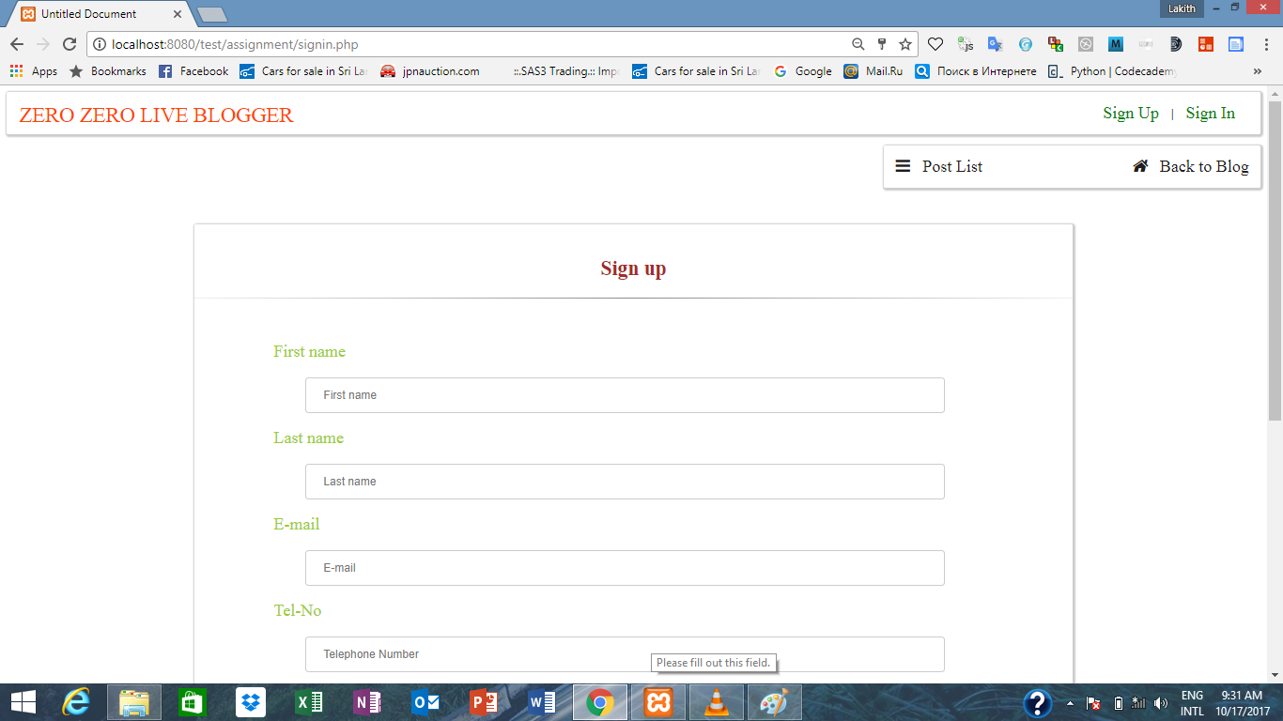

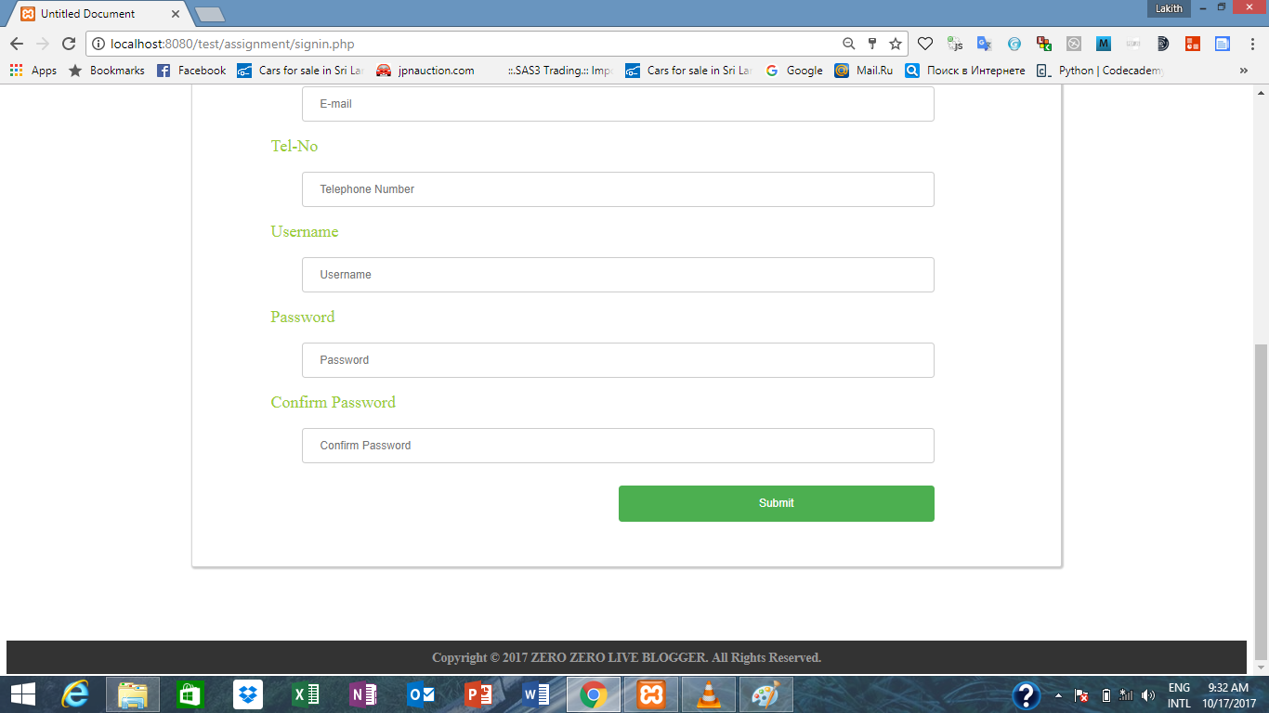

IF some field is empty you wont be allow to submit. Also until the password matches button will not get activate.



After passwords got match button will get active.

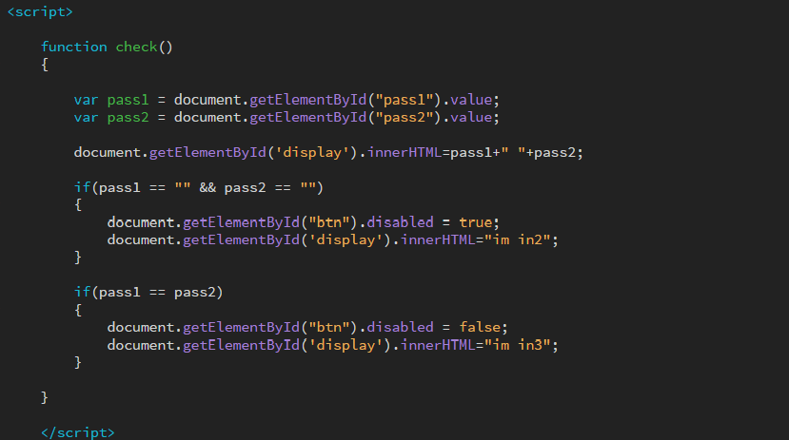

But if you are logged in using another account even if you try to type the link and access this page, you won’t be able to do that, because the page checks wather the cookies and sessions are set or not.

It only allows to access this page if there is no cookies or sessions in the browser.

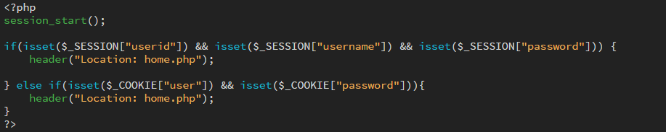

Admins cannot assign using the website. If user want to make a user as a admin user must do it manually by accessing the database table “user_details”. User must change the user_level to ‘1’.(I thought assign the users as admins manually is more reliable. ) also passwords are not hashed. Passwords will store the database as the user entered to the form.

Sign In

By using this page users can log in to there accounts. Admin Users and Non-admin users both are sign in using this page. Same as sign up page you cannot access this page again after logged in.

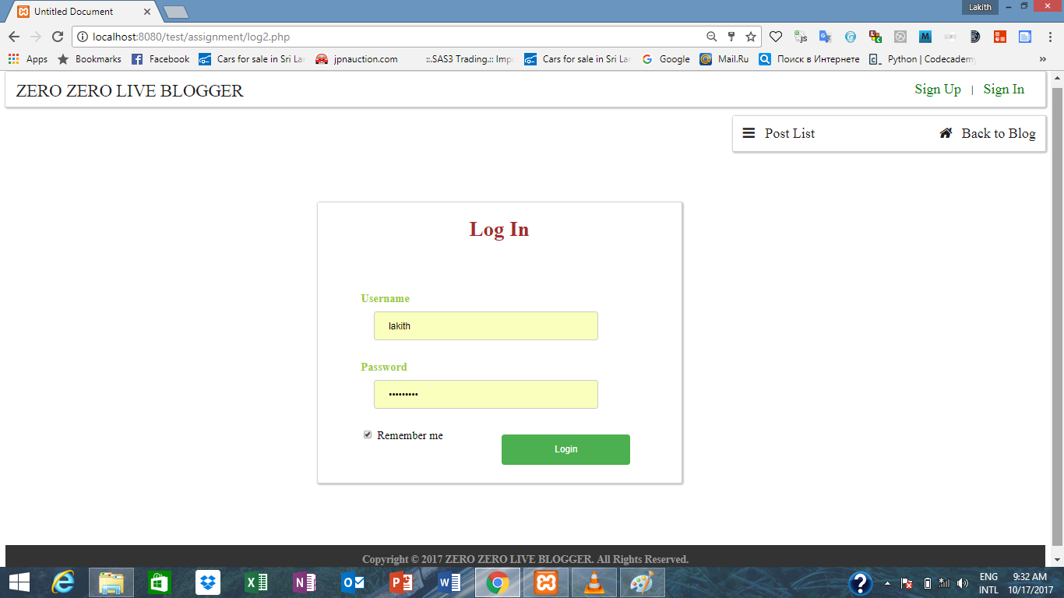

View Blog.

You can view this page by clicking the link “Back to blog” on home page.

This page views user details. By using the cookie and session data ,details of the user will be retrieved.

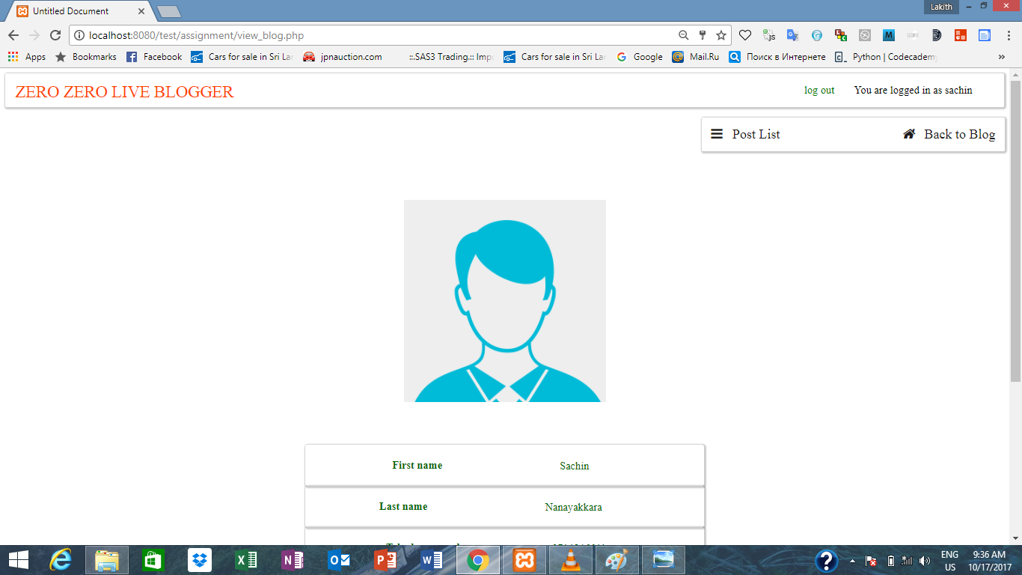

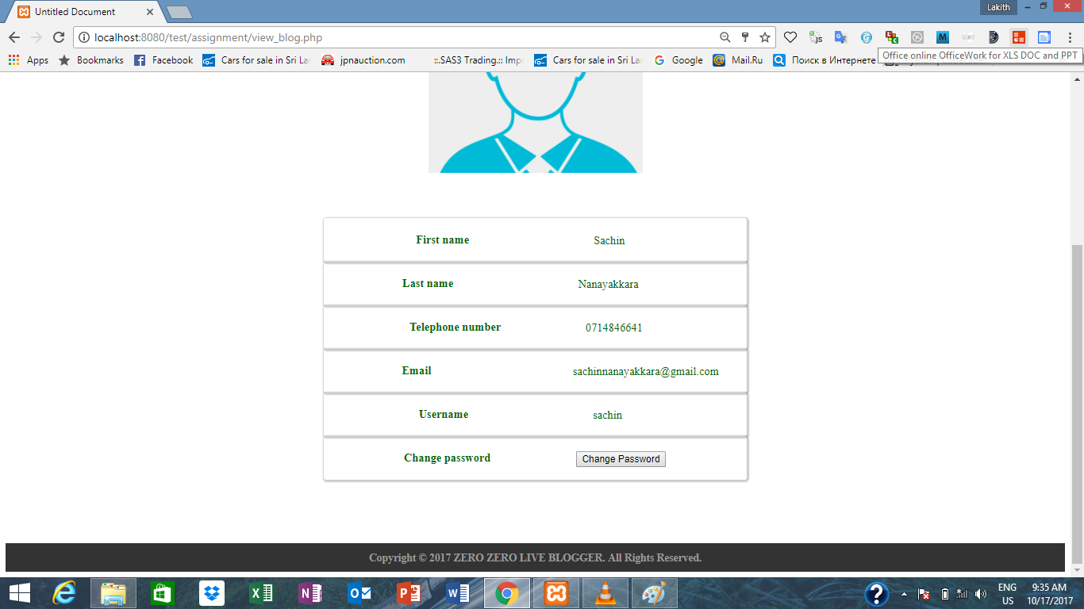

Without signing to an account you cannot access this page.

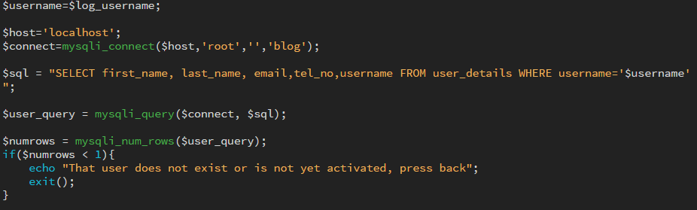

Also you can change the password using this page by simply clicking the change password button. Then the password change form will be displayed.

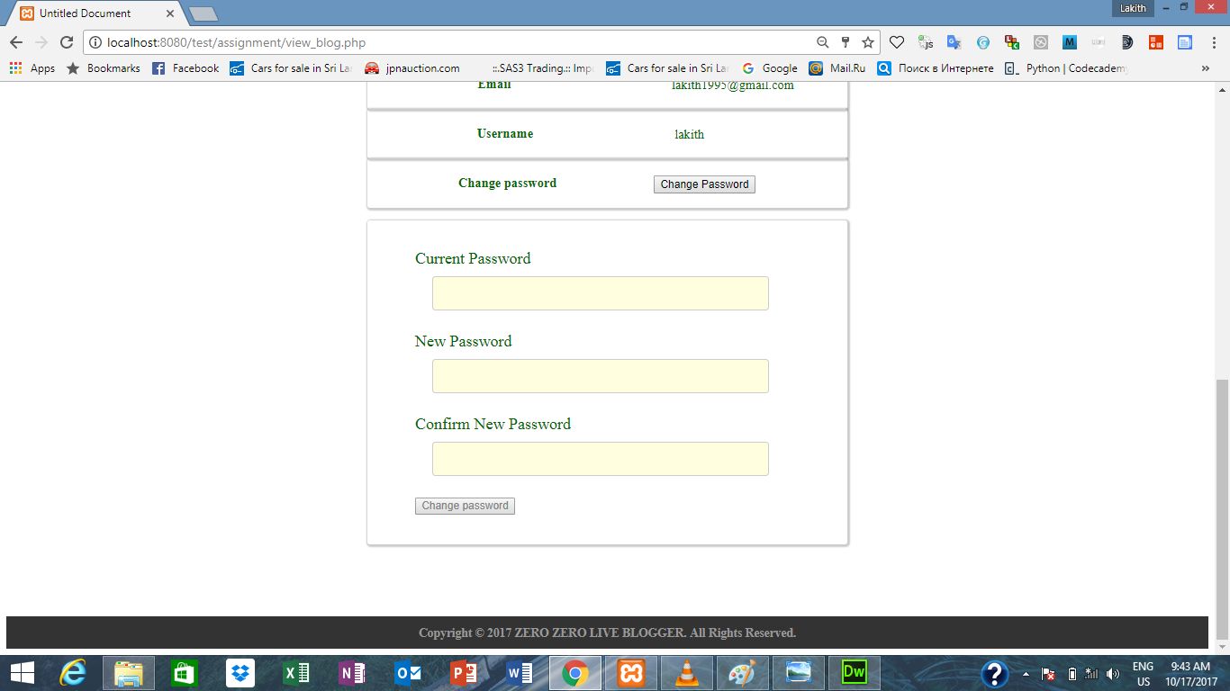

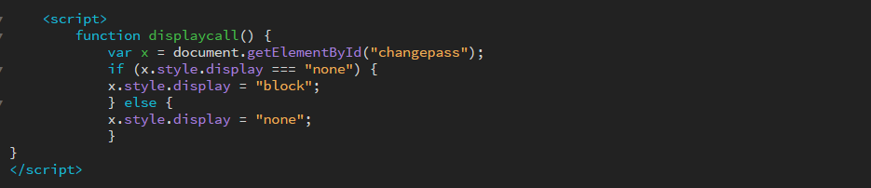

You have to type your current password bore adding a new password. Until you add the correct old password “New password” and “Confirm New Password” text boxes will got disabled.

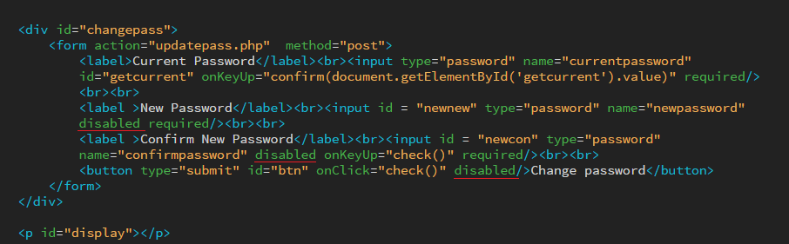

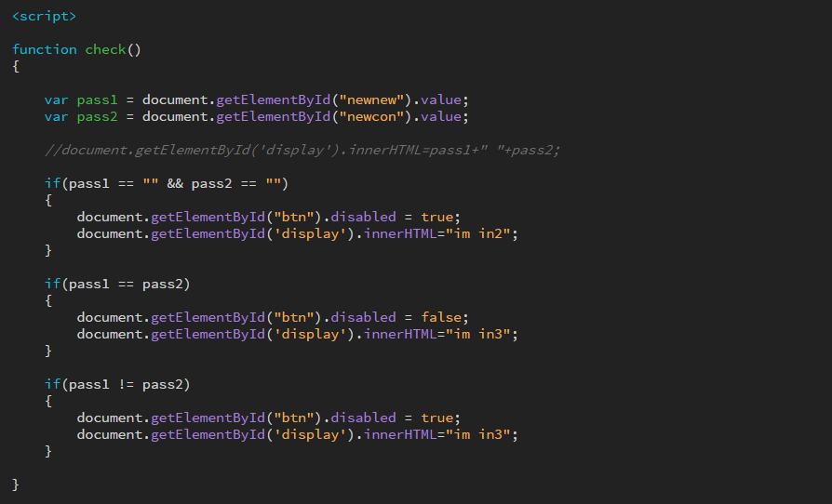

View Posts.

By clicking any post on the home page you can view the content and author of that post. As well as you can view and add comments.

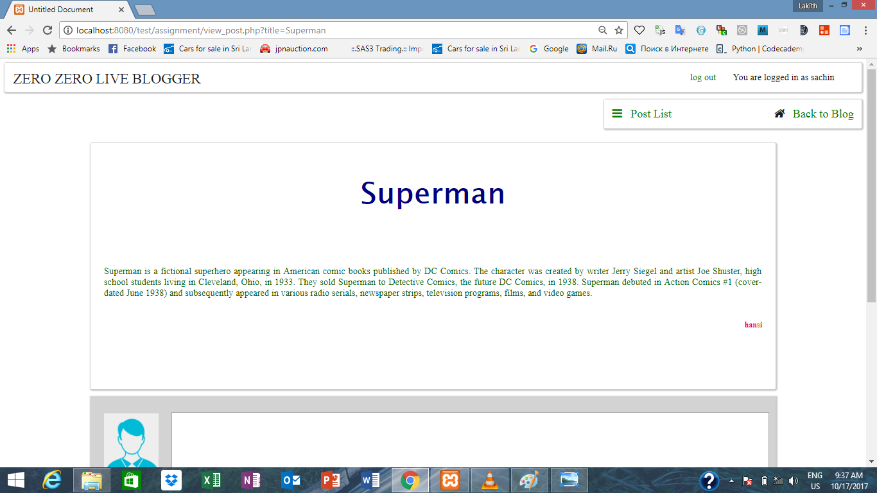

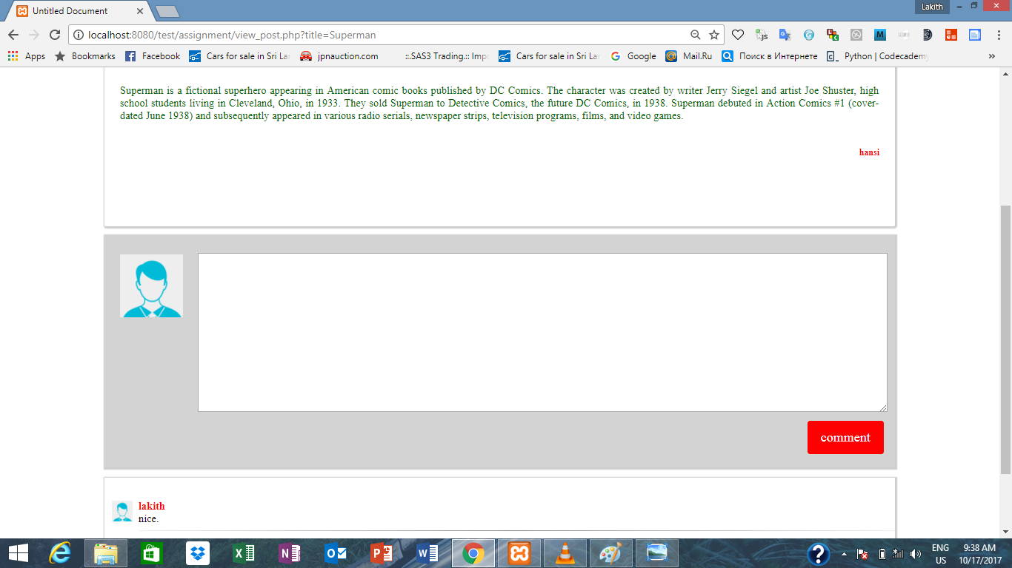

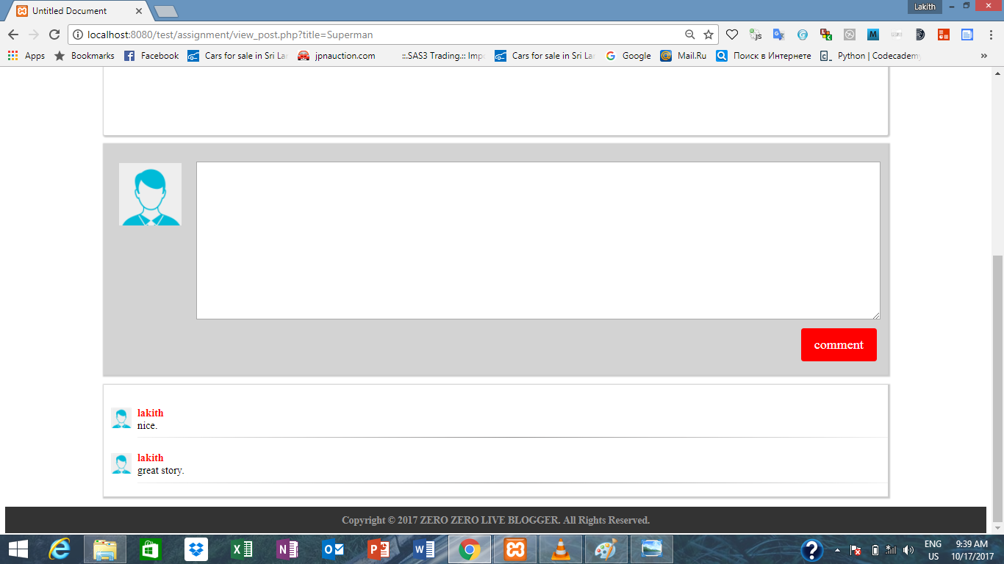

By clicking any post title on home page , the title is passed to view blog page. Using the php get method blogger suite retrieve the title and display the content. Author and comments of that post.

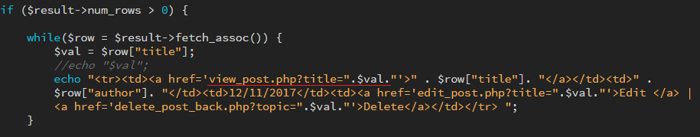

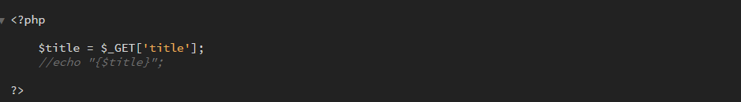

You can add any number of comments to a particular post. All the comments will be stored in a database table. But only 10 comments will be displayed.

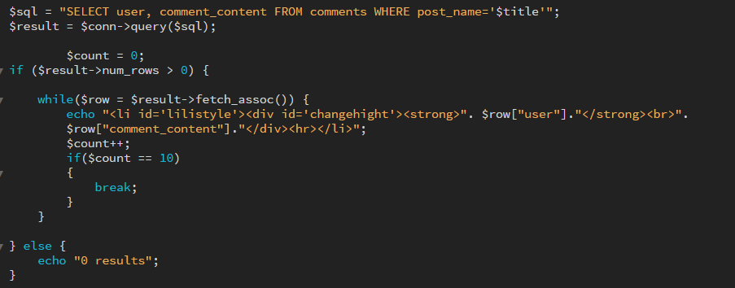

Even if there is more than 10 comments, after displaying 10 comments , loop will be break. So the page wont display more than 10 comments.

ADD YOUR POST.

By using this page users can add posts . Author will be retrieved using cookie and session data. Before add a post you have to logged in otherwise blog wont allow to add any posts.

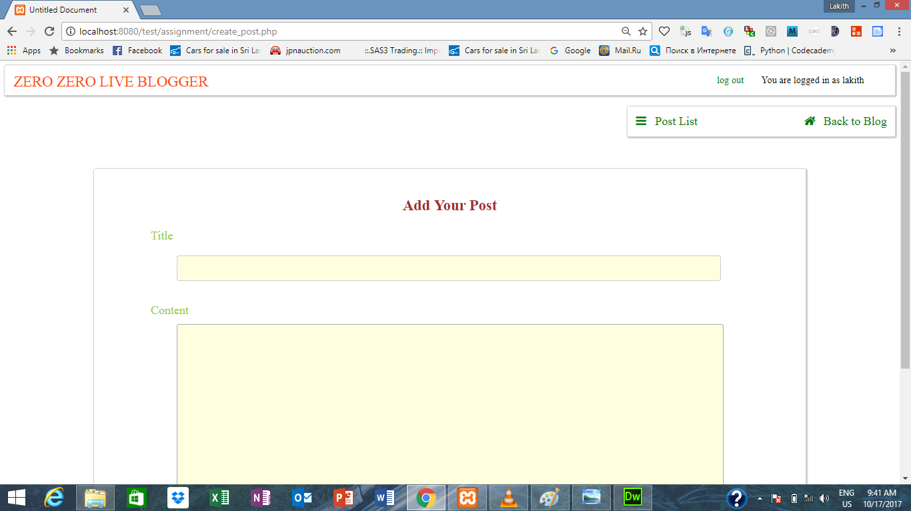

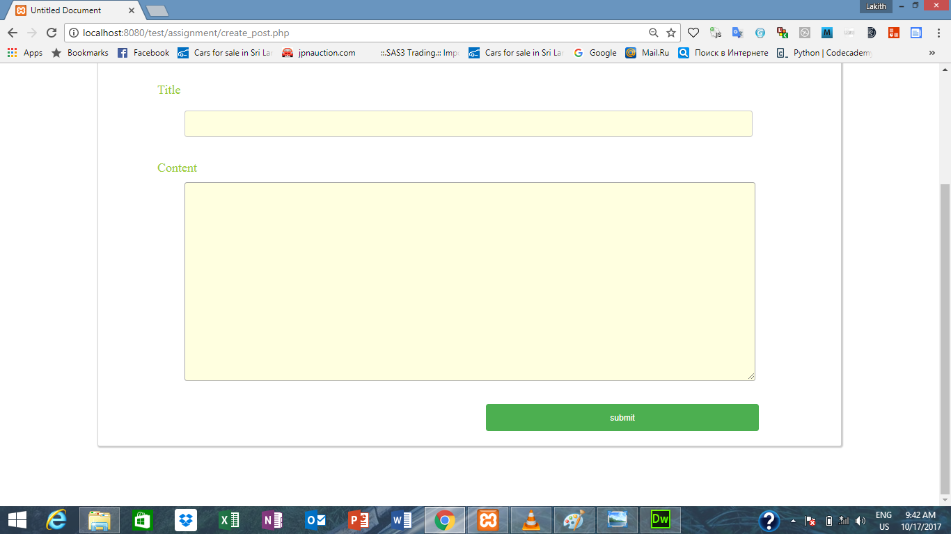

Edit Your Post

By using this page you can edit your posts. By Using this page you can edit the title and the content of a particular post. Current title and content will be displayed on related tabs.

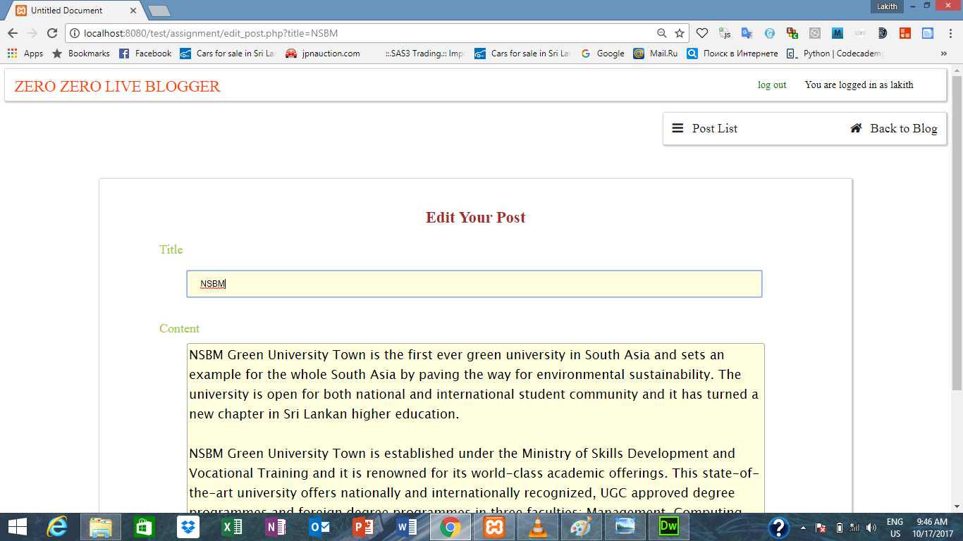

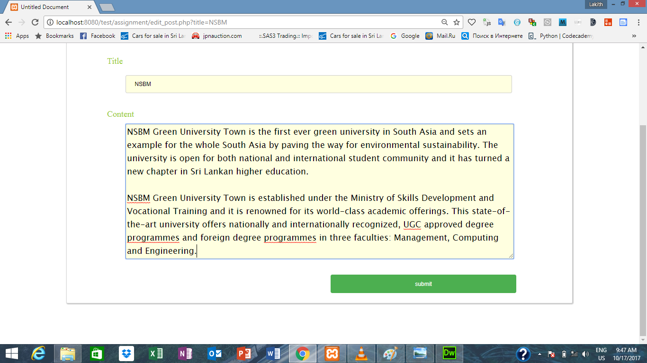

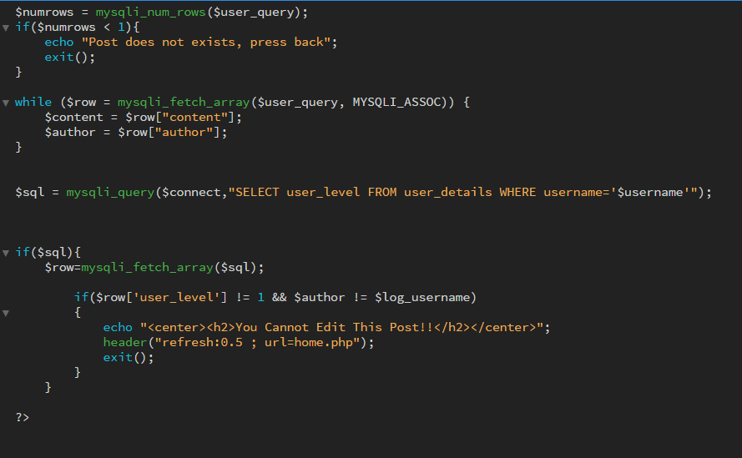Only the admin and the author can only edit any post. Others cannot edit posts or access this page.

Delete Posts

Only the admin and author and delete any pots. Others cannot delete posts.

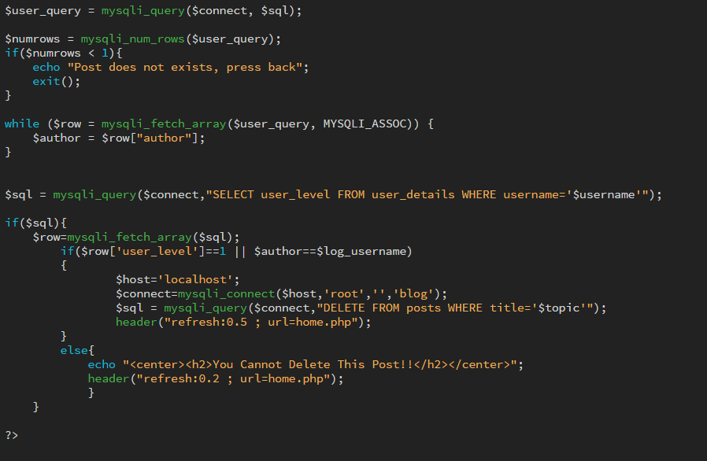

Delete Users.

Only the admin can perform this operation. The table displays the current non-admin users by simply clicking the delete button admins can delete users.

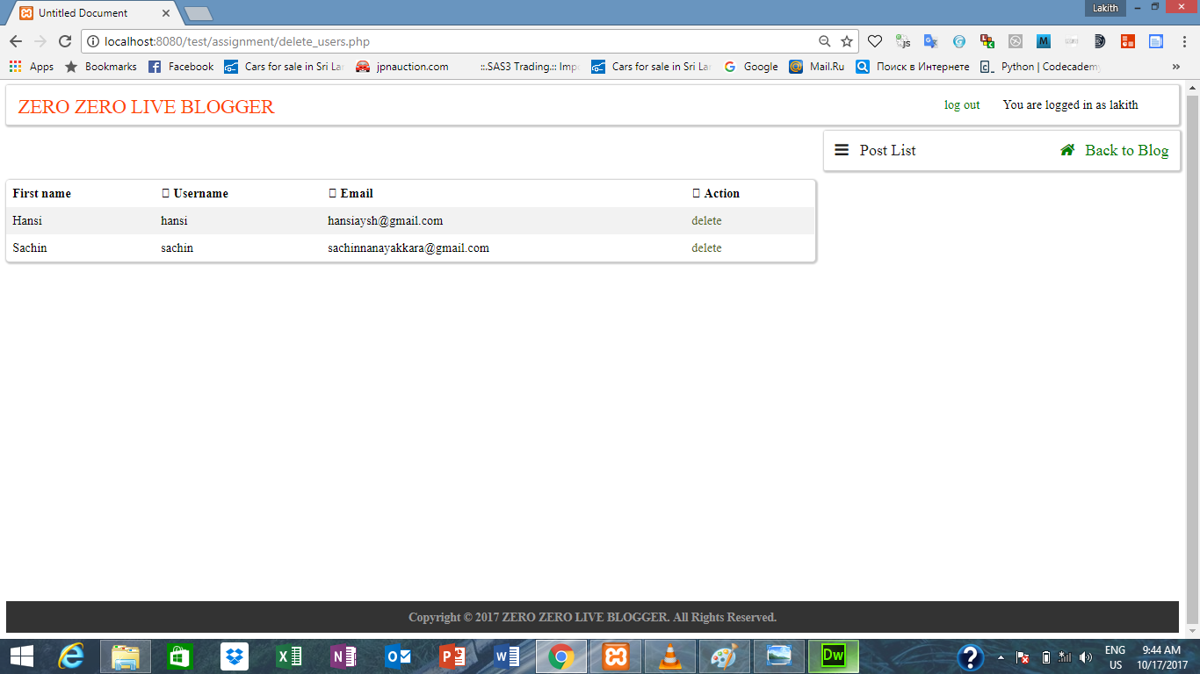

Admin users won’t display on this table.

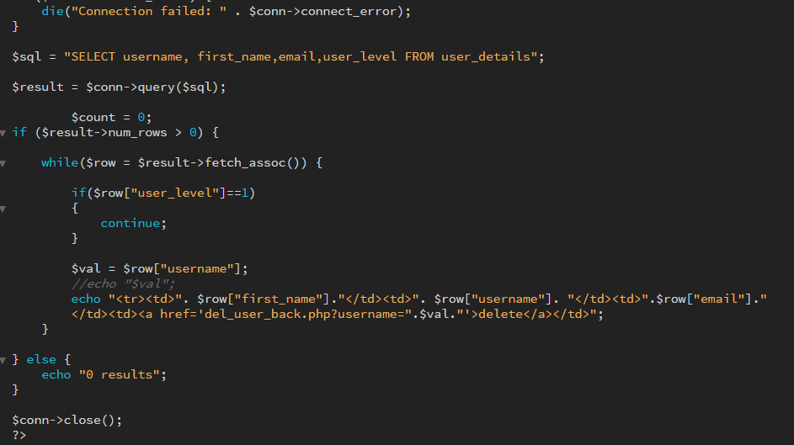

Responsiveness

iPhone5

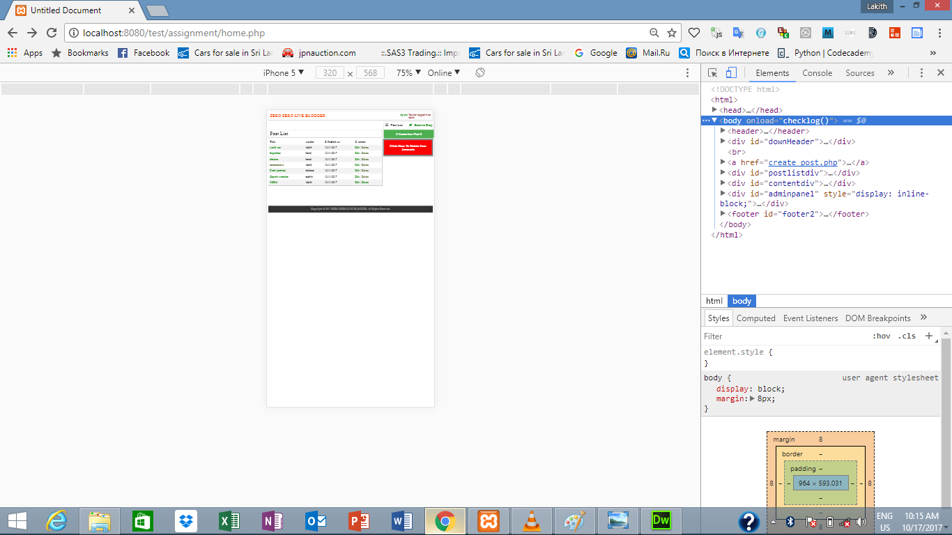

iPhone 6 Plus

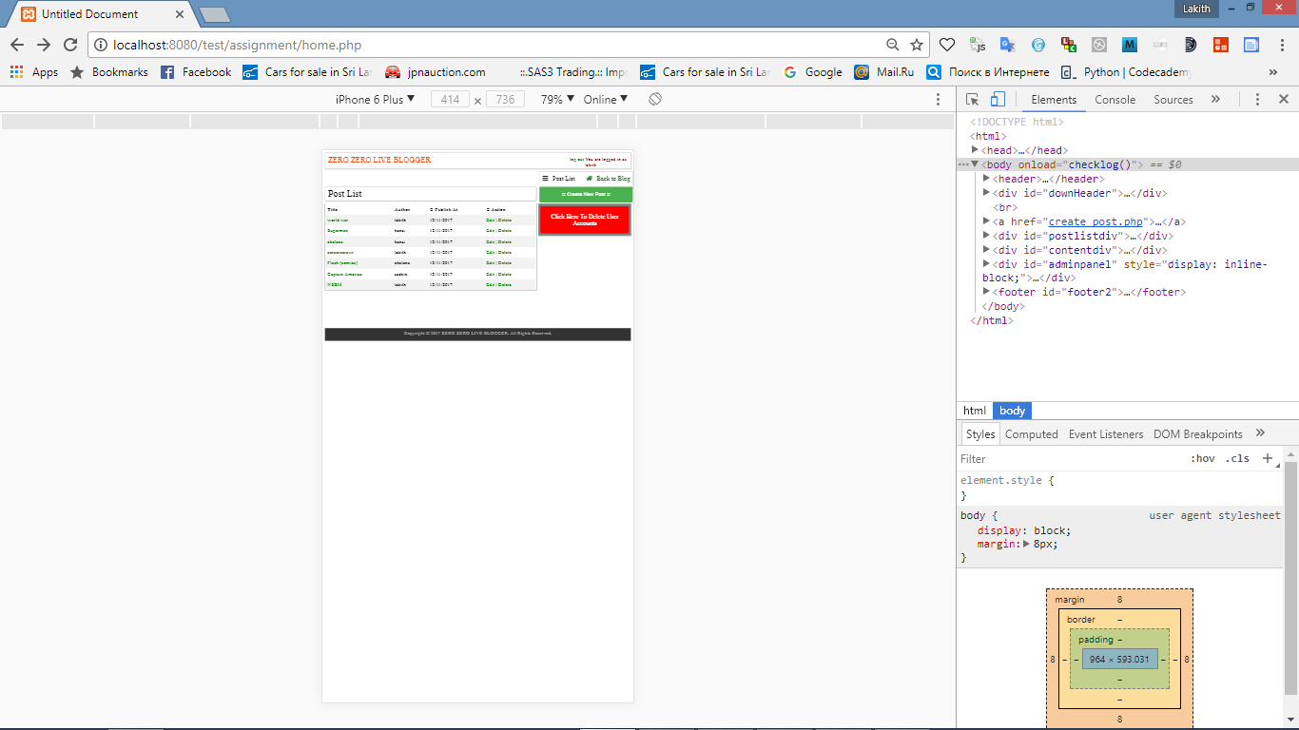

iPad Pro

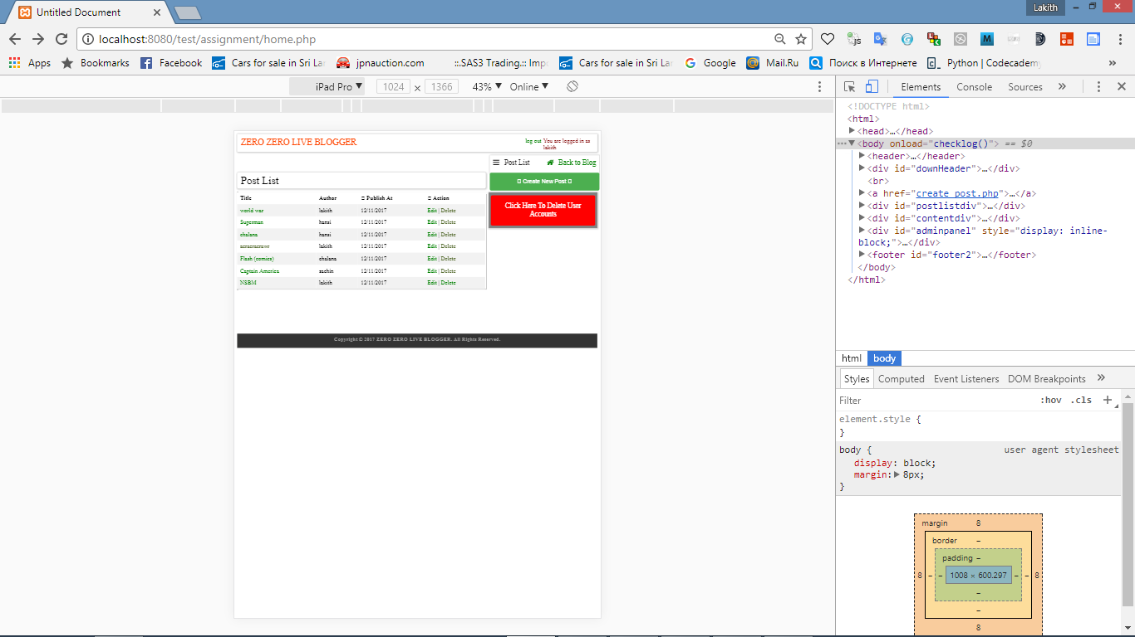

Galaxy S5

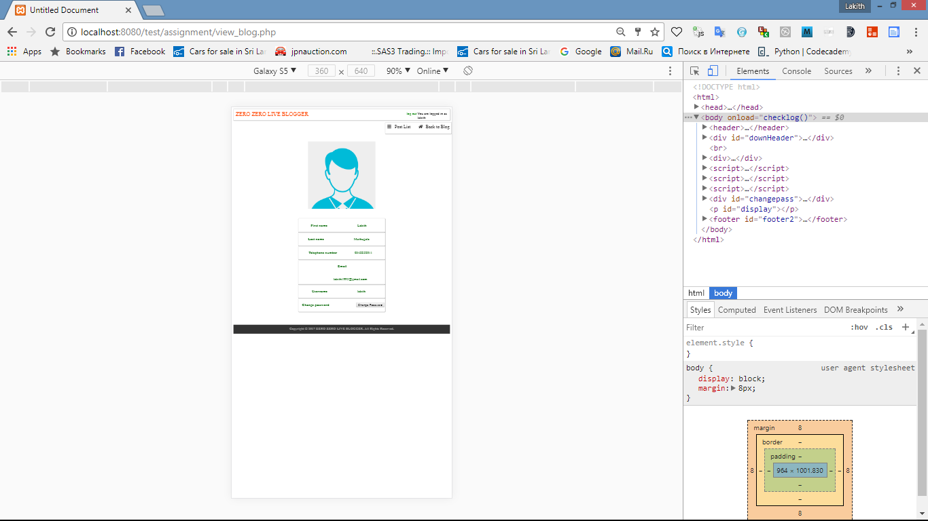

iPhone 5

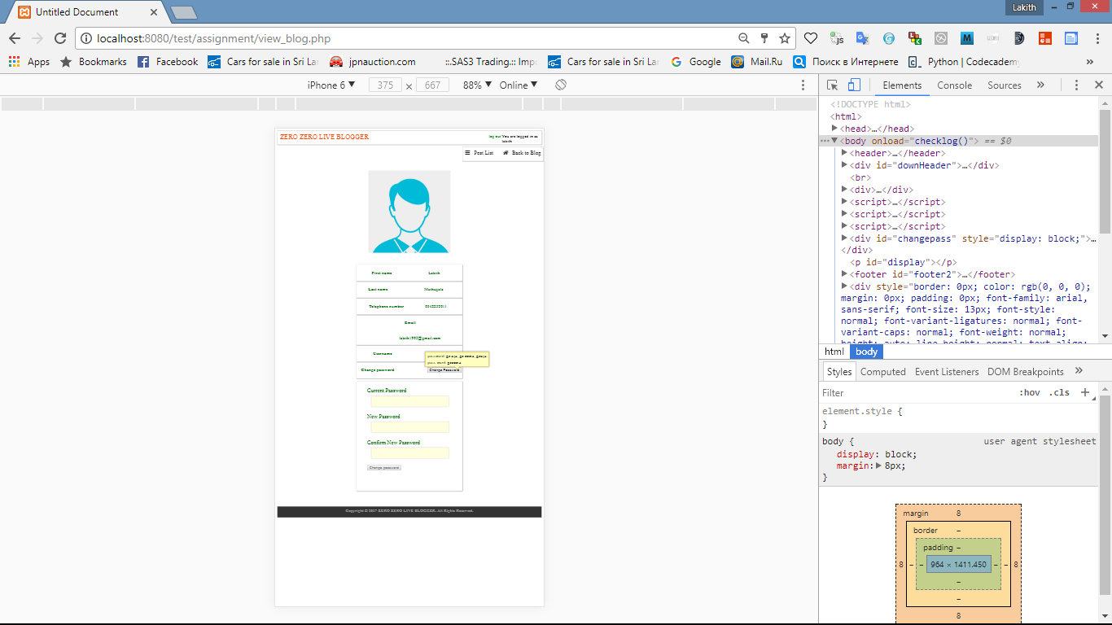

iPad pro

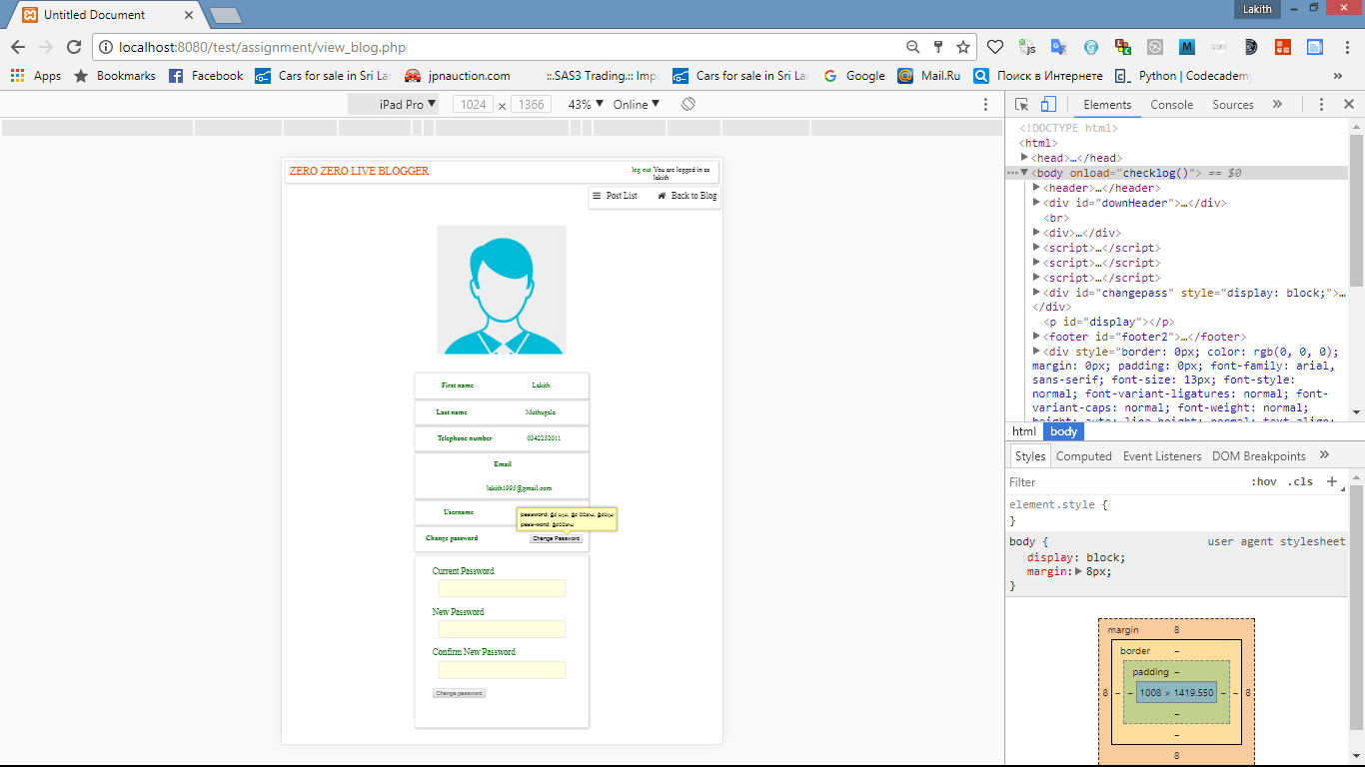

iPad pro

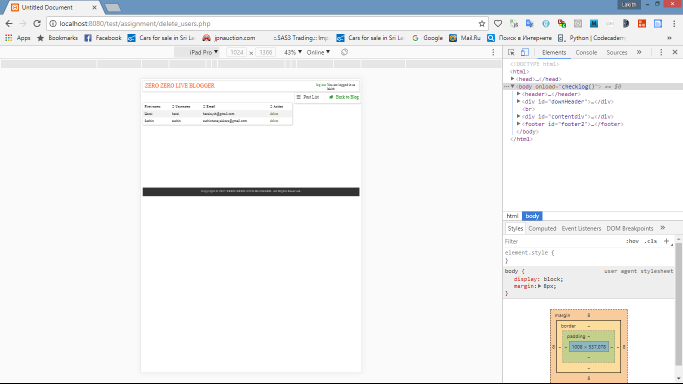

iPhone 6

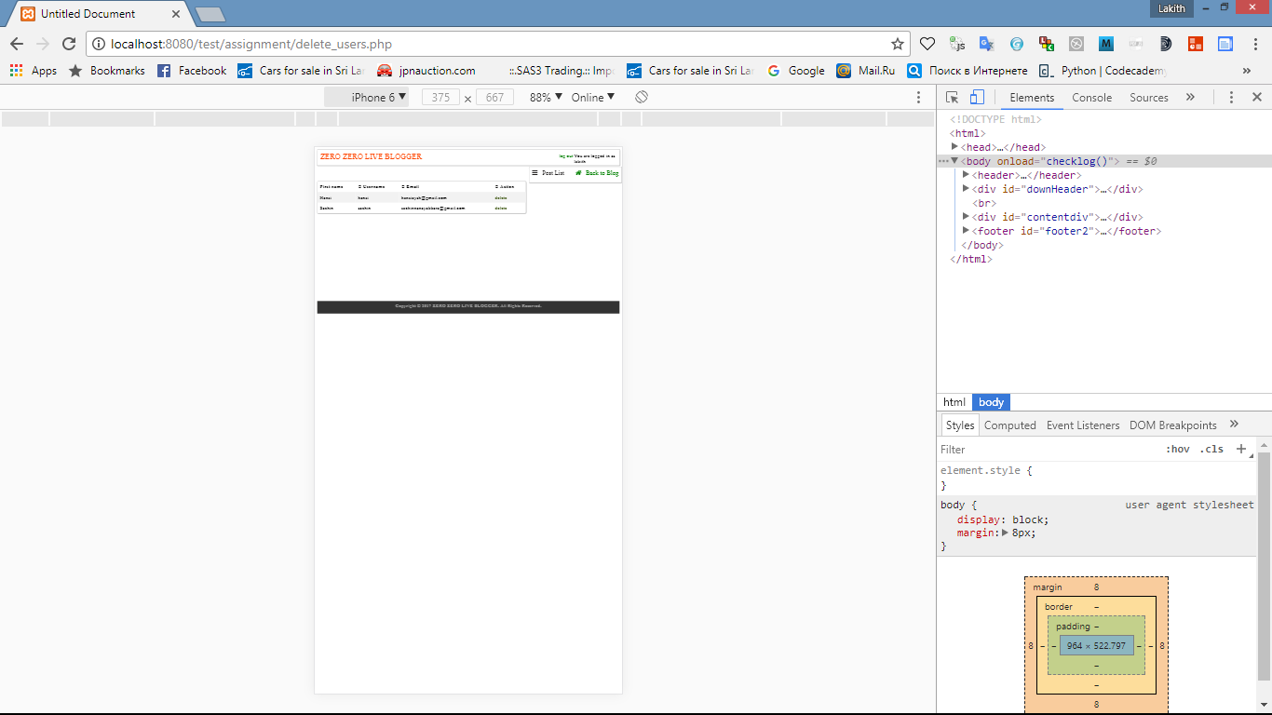

Galaxy S5

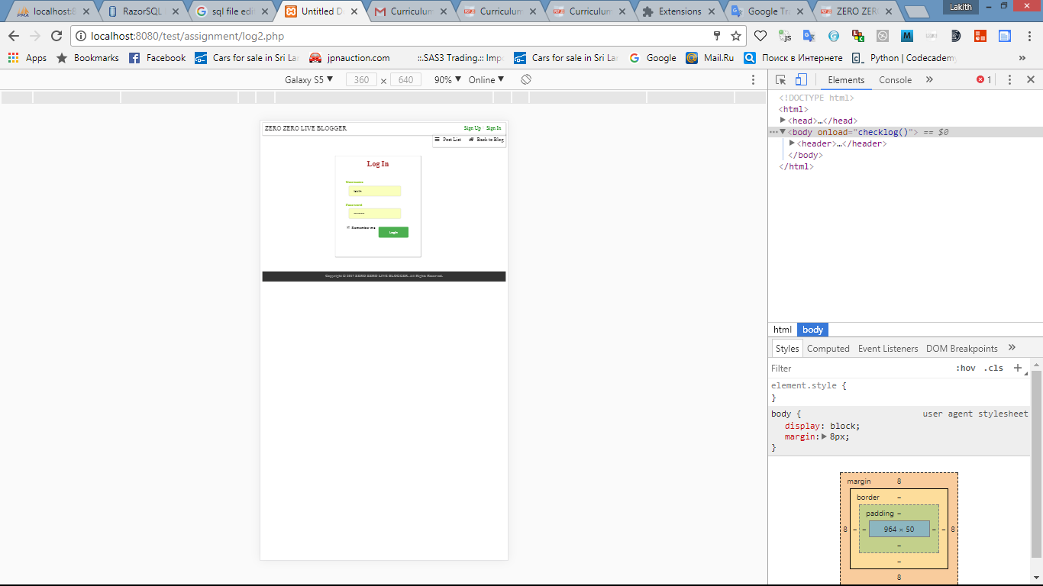

iPhone 6 Plus

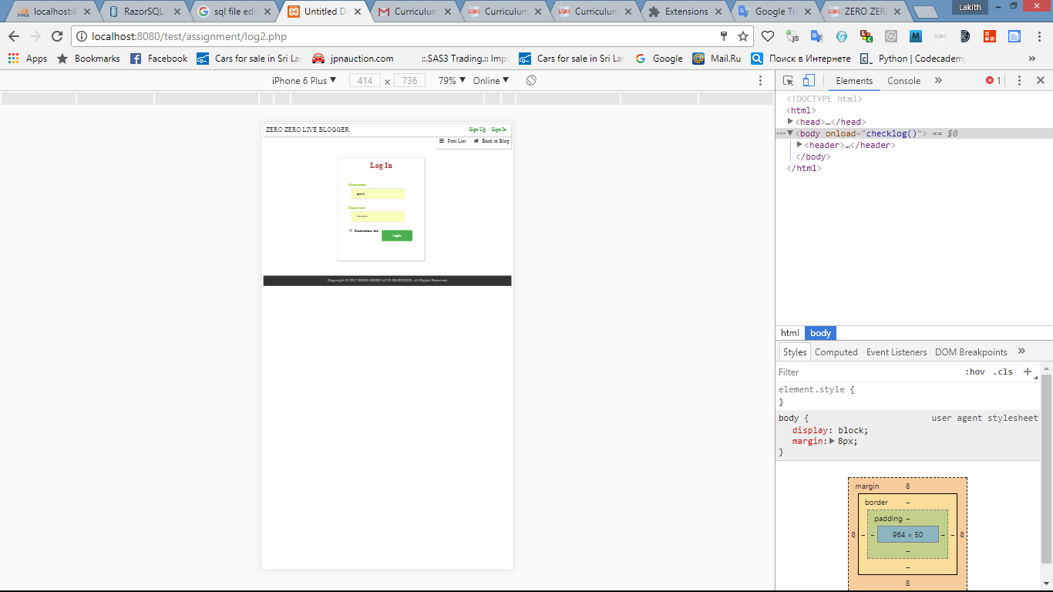

iPad Pro

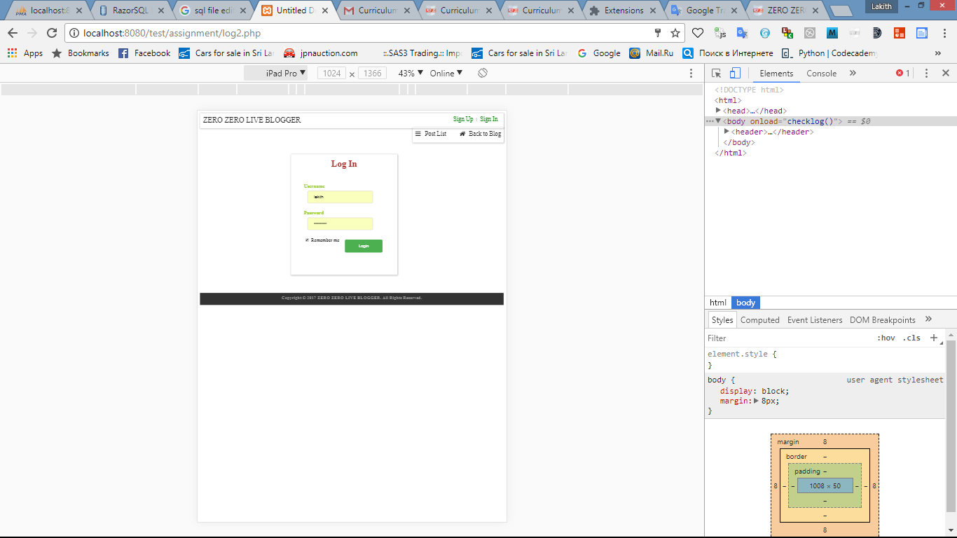

iPhone 6

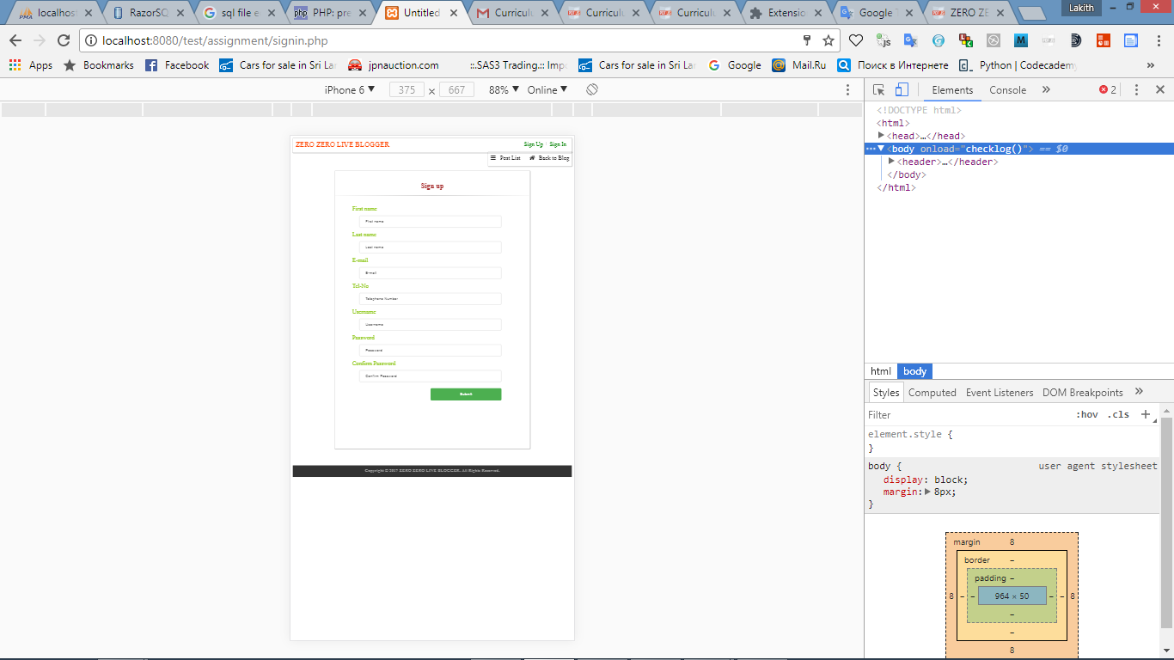

iPad Pro

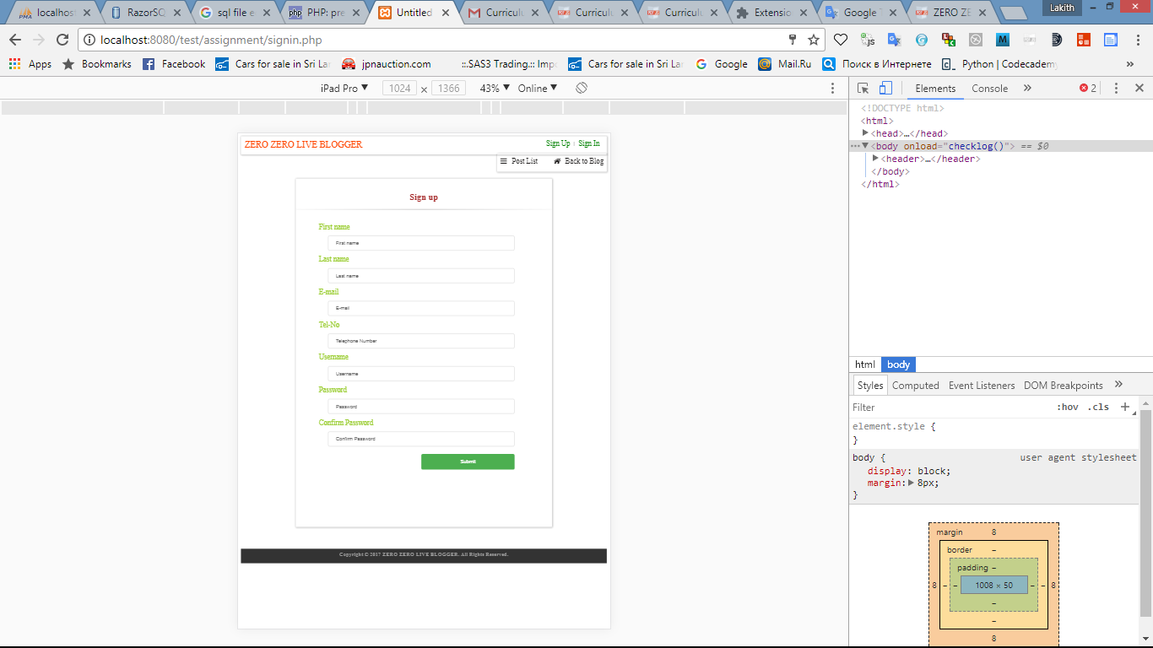

Galaxy S5

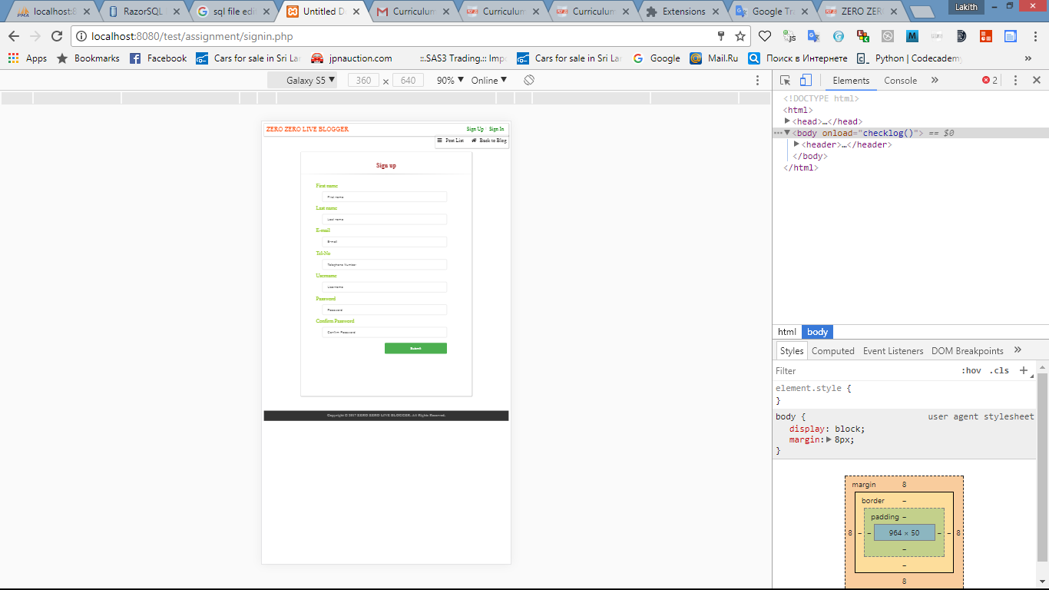

Database tables.

Data base name is blog. It contains 3 tables.

1. user_details.
2. posts.
3. comments.

* user_details

This table contains details about users.it has 8 coloums.

* email data type – varchar(50).
* first_name data type – varchar(50).
* id data type – int – auto increment.
* last_name data type – varchar(50).
* password data type – varchar(50).
* tel_no data type – varchar(50).
* username data type – varchar(50).
* user_level data type – int.



* posts

This table contains details about posts. It has 5 coloums.

* author data type – varchar(50).
* content long text.
* date data type – varchar(50).
* id data type – int – auto increment.
* title data type – varchar(50).

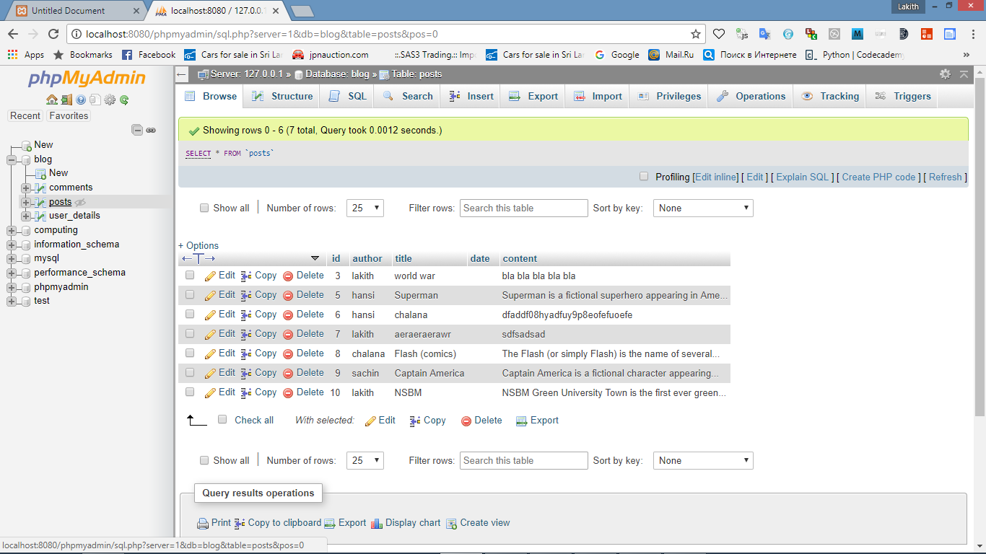

* comments

This table contains user comments.This table has

* comment_content data type – varchar(50).
* id data type –int- auto increment.
* post_name data type – varchar(50).
* user data type – varchar(50).

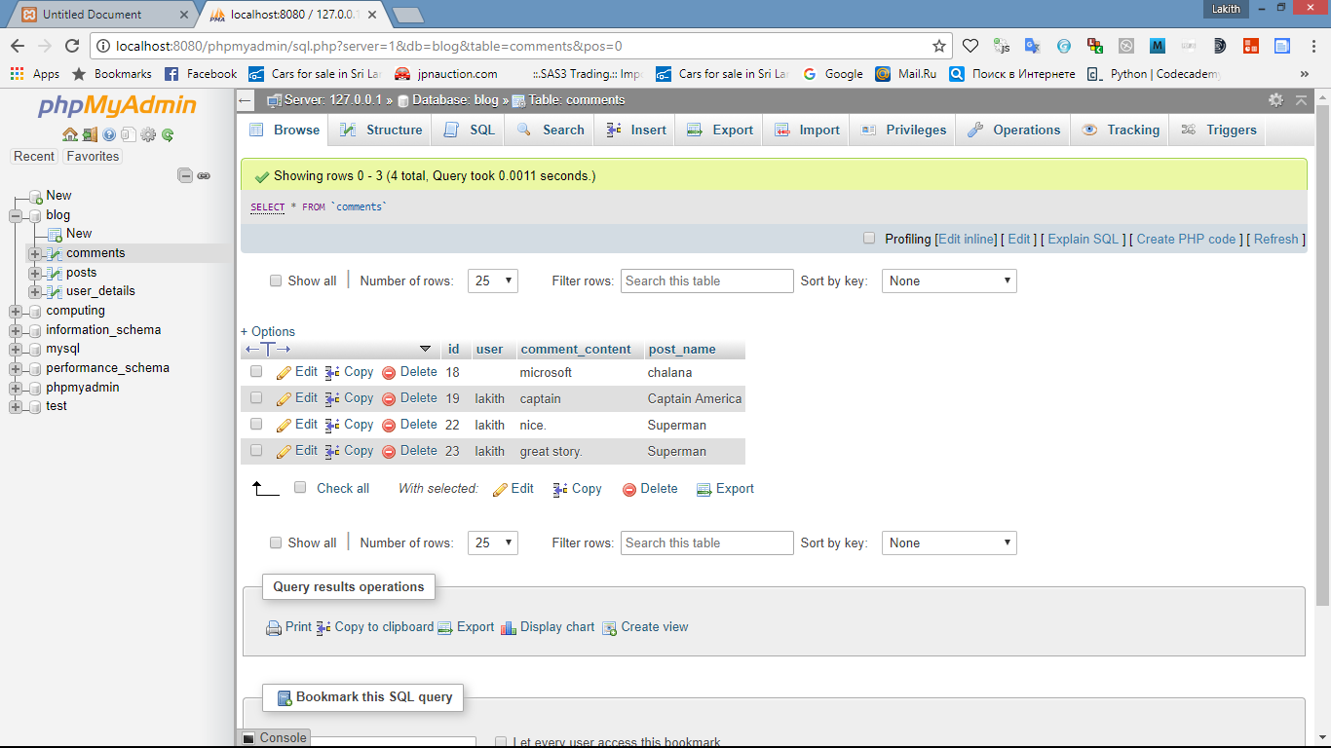

SQL FILE

-- phpMyAdmin SQL Dump

-- version 4.7.4

-- https://www.phpmyadmin.net/

--

-- Host: 127.0.0.1

-- Generation Time: Oct 14, 2017 at 03:41 PM

-- Server version: 10.1.26-MariaDB

-- PHP Version: 7.1.9

SET SQL_MODE = "NO_AUTO_VALUE_ON_ZERO";

SET AUTOCOMMIT = 0;

START TRANSACTION;

SET time_zone = "+00:00";

/*!40101 SET @OLD_CHARACTER_SET_CLIENT=@@CHARACTER_SET_CLIENT */;

/*!40101 SET @OLD_CHARACTER_SET_RESULTS=@@CHARACTER_SET_RESULTS */;

/*!40101 SET @OLD_COLLATION_CONNECTION=@@COLLATION_CONNECTION */;

/*!40101 SET NAMES utf8mb4 */;

--

-- Database: `blog`

CREATE DATABASE blog;

use blog;

-- --------------------------------------------------------

--

-- Table structure for table `comments`

--

CREATE TABLE `comments` (

`id` int(12) NOT NULL,

`user` varchar(50) NOT NULL,

`comment_content` longtext NOT NULL,

`post_name` varchar(50) NOT NULL

) ENGINE=InnoDB DEFAULT CHARSET=latin1;

--

-- Dumping data for table `comments`

--

INSERT INTO `comments` (`id`, `user`, `comment_content`, `post_name`) VALUES

(1, 'hansi', 'lakith', ''),

(2, 'hansi', 'this is a awsome blog', ''),

(3, 'hansi', 'bla bla bla', ''),

(4, '', 'bla bla bla', ''),

(5, 'hansi', 'bla bla', ''),

(6, 'hansi', '4324234', ''),

(7, 'hansi', '4324234', ''),

(8, 'hansi', '2132132132321312321', ''),

(9, '', 'rgfrwhierwgrwgrwgfwg', ''),

(10, 'hansi', 'name', ''),

(11, 'hansi', 'name', ''),

(12, '', 'heliumx', ''),

(13, '', 'super man', ''),

(14, '', 'super man', 'Superman'),

(15, '', 'super man', 'Superman'),

(16, '', 'head', 'Superman'),

(17, '', 'comment', 'Superman'),

(18, '', 'microsoft', 'chalana');

-- --------------------------------------------------------

--

-- Table structure for table `posts`

--

CREATE TABLE `posts` (

`id` int(15) NOT NULL,

`author` varchar(50) NOT NULL,

`title` varchar(50) NOT NULL,

`date` varchar(50) NOT NULL,

`content` text NOT NULL

) ENGINE=InnoDB DEFAULT CHARSET=latin1;

--

-- Dumping data for table `posts`

--

INSERT INTO `posts` (`id`, `author`, `title`, `date`, `content`) VALUES

(1, '', 'lakith', '', 'dsadsadsad'),

(2, 'lakith', 'lakith', '', 'dsadsadsad'),

(3, 'lakith', 'world war', '', 'bla bla bla bla bla'),

(4, 'hansi', 'lakith22', '', 'sdfsadsadsad'),

(5, 'hansi', 'Superman', '', 'Superman is a fictional superhero appearing in American comic books published by DC Comics. The character was created by writer Jerry Siegel and artist Joe Shuster, high school students living in Cleveland, Ohio, in 1933. They sold Superman to Detective Comics, the future DC Comics, in 1938. Superman debuted in Action Comics #1 (cover-dated June 1938) and subsequently appeared in various radio serials, newspaper strips, television programs, films, and video games. With this success, Superman helped to create the superhero archetype and establish its primacy within the American comic book.[2]'),

(6, 'hansi', 'chalana', '', 'dfaddf08hyadfuy9p8eofefuoefe'),

(7, 'lakith', 'aeraeraerawr', '', 'sdfsadsad'),

(8, 'chalana', 'Flash (comics)', '', 'The Flash (or simply Flash) is the name of several superheroes appearing in comic books published by DC Comics. Created by writer Gardner Fox and artist Harry Lampert, the original Flash first appeared in Flash Comics #1 (cover date January 1940/release month November 1939).[1] Nicknamed the &quot;Scarlet Speedster&quot;, all incarnations of the Flash possess &quot;super speed&quot;, which includes the ability to run, move, and think extremely fast, use superhuman reflexes, and seemingly violate certain laws of physics.');

-- --------------------------------------------------------

--

-- Table structure for table `user_details`

--

CREATE TABLE `user_details` (

`id` int(15) NOT NULL,

`first_name` varchar(50) NOT NULL,

`last_name` varchar(50) DEFAULT NULL,

`tel_no` varchar(50) DEFAULT NULL,

`email` varchar(50) NOT NULL,

`username` varchar(50) NOT NULL,

`password` varchar(50) NOT NULL

) ENGINE=InnoDB DEFAULT CHARSET=latin1;

--

-- Dumping data for table `user_details`

--

INSERT INTO `user_details` (`id`, `first_name`, `last_name`, `tel_no`, `email`, `username`, `password`) VALUES

(1, 'Lakith', 'Muthugala', '0342252011', 'lakith1995@gmail.com', 'lakith', 'sumangala'),

(2, 'Hansi', 'Yapa', '0710873073', 'hansiaysh@gmail.com', 'hansi', 'pass'),

(3, 'Chalana', 'Kalpitha', '0714846641', 'chalanakalpitha@gmail.com', 'chalana', 'pass');

--

-- Indexes for dumped tables

--

--

-- Indexes for table `comments`

--

ALTER TABLE `comments`

ADD PRIMARY KEY (`id`);

--

-- Indexes for table `posts`

--

ALTER TABLE `posts`

ADD PRIMARY KEY (`id`);

--

-- Indexes for table `user_details`

--

ALTER TABLE `user_details`

ADD PRIMARY KEY (`id`);

--

-- AUTO_INCREMENT for dumped tables

--

--

-- AUTO_INCREMENT for table `comments`

--

ALTER TABLE `comments`

MODIFY `id` int(12) NOT NULL AUTO_INCREMENT, AUTO_INCREMENT=19;

--

-- AUTO_INCREMENT for table `posts`

--

ALTER TABLE `posts`

MODIFY `id` int(15) NOT NULL AUTO_INCREMENT, AUTO_INCREMENT=9;

--

-- AUTO_INCREMENT for table `user_details`

--

ALTER TABLE `user_details`

MODIFY `id` int(15) NOT NULL AUTO_INCREMENT, AUTO_INCREMENT=4;

COMMIT;

/*!40101 SET CHARACTER_SET_CLIENT=@OLD_CHARACTER_SET_CLIENT */;

/*!40101 SET CHARACTER_SET_RESULTS=@OLD_CHARACTER_SET_RESULTS */;

/*!40101 SET COLLATION_CONNECTION=@OLD_COLLATION_CONNECTION */;

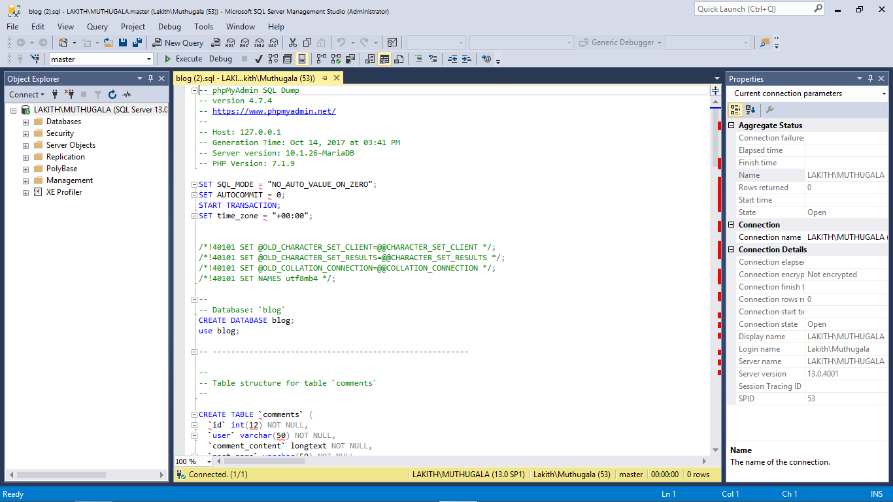

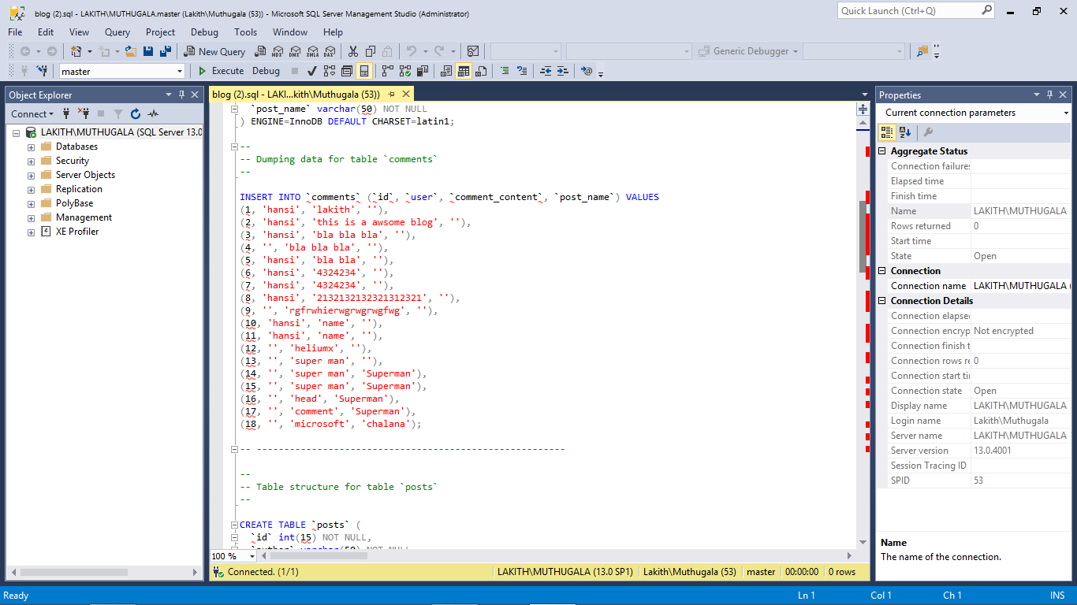

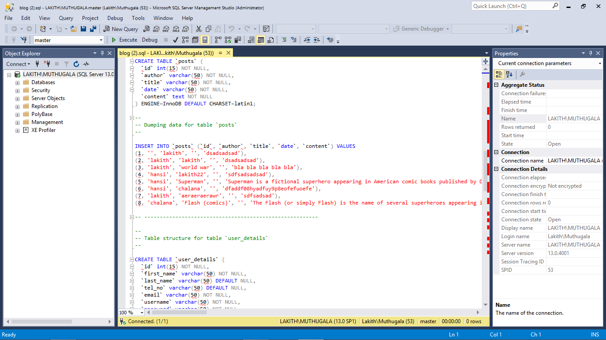

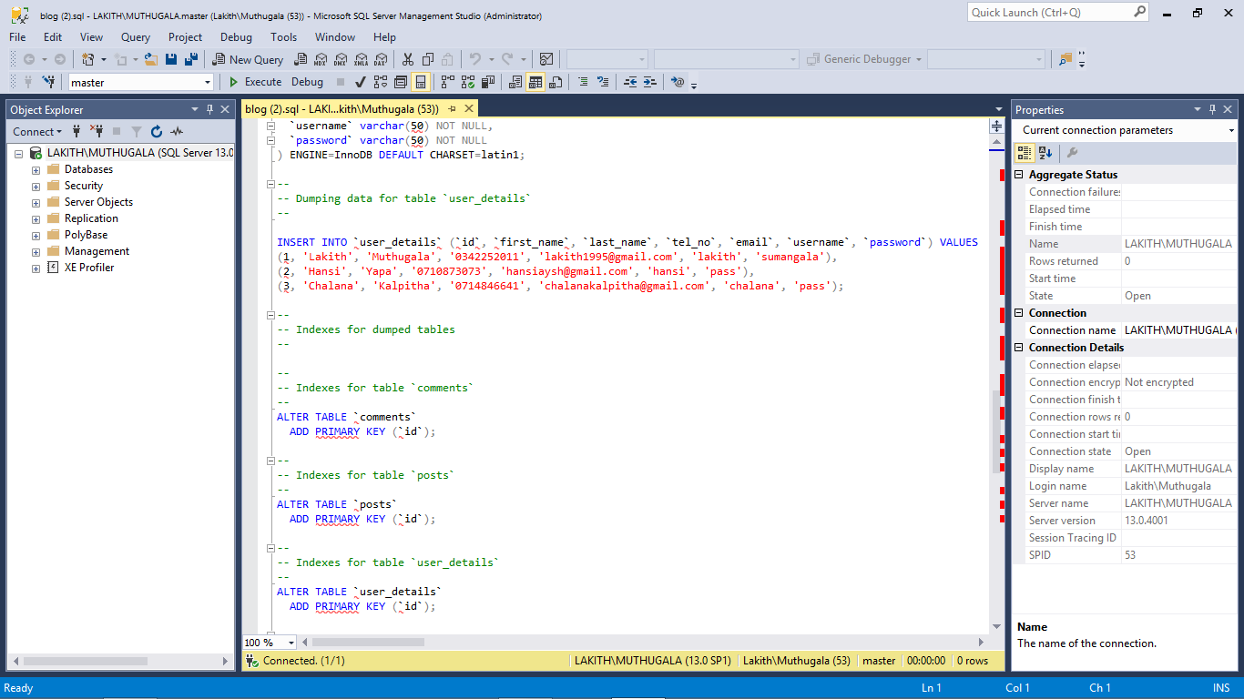

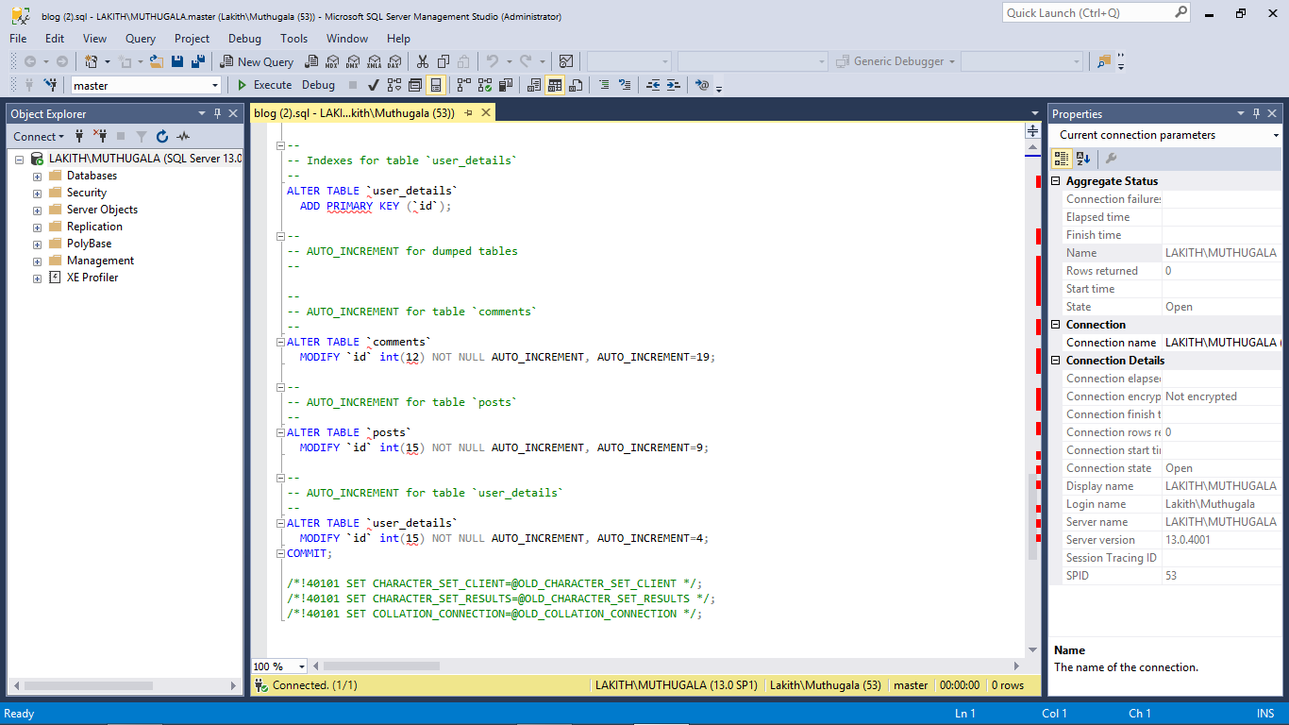

End of the read me file.